92.07.07
From Leonard Rodway
RB MSS M17, Library, Royal Botanic Gardens Melbourne.

151 Macquarie St,
Hobart.
July 7th /92.
Dear Baron,
I must once again encroach on your valuable time. The enclosed sedge, found by Mr Wm Fitzgerald I can only make a Carpha only the Hypogynous scales are only as long as the nut. I am aware ther[e] is up to the present only one species in Carpha, but looseness of the inflorescence, perfectly distichous glumes & feathery scales which are six in number prevent me finding another place for it. The nut is broadly obovate black with 3 slightly raised ribs.
It grows at Georges Bay.
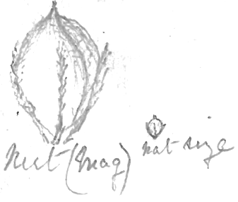
I also enclose a piece of a very common Eucalypt about here. Habitat: glaucous drooping, bark smooth ashy white. The venation of the leaves appear to me to resemble E. amygdalina but the fruit is more that of E. obliqua. It is always looked on here as E. viminalis & is the plant alluded to by Spicer as a white Gum growing near Huon Rd Toll-Bar. Is it a glaucous form of E. amygdalina var radiata. Would you kindly also inform me Is Gum-topped stringy bark (E. haemastoma) now included in E obliqua or which species.
Also, am I to consider the large Eucalypt described by you in Trans. Roy. Soc Tas. 1886, from specimens sent you by T. B. Moore as a large growth of E. vernicosa?
Yours Faithfully
L Rodway.

P.S. I will endeavour to send you further specimens of the intermediate type of Pterostylis in a week or so. The plant figured in Hook. Fl. Tas. as P. nana is quite glabrous & is very common in flower in September. I have always considered it P. pedunculata. The one figured in Hook. as P. pedunculata flowers a little later & I have always taken it for P. furcata. If you wish I will forward good specimens when they are out
L.R.

Carpha
Eucalyptus amygdalina
Eucalyptus amygdalina var. radiata
Eucalyptus haemastoma
Eucalyptus obliqua
Eucalyptus vernicosa
Eucalyptus viminalis
Pterostylis furcata
Pterostylis pedunculata
Pterostylis praecox

MS found with a specimen of Eucalyptus tenuiramus (MEL 231659). MS annotation by M: 'Answ 10/7/92'. Letter not found.
editorial addition. Text runs off the page.
Tas. At this point Rodway has included pencil sketches of the nut 'mag' [i.e. magnified] and 'nat size': 92-07-07_image01.jpg In the original the magnified nut is 20 mm high.
B87.13.05.
J. Hooker (1860), part 2, tab. 114, B.
J. Hooker (1860), part 2, tab. 114, A.

